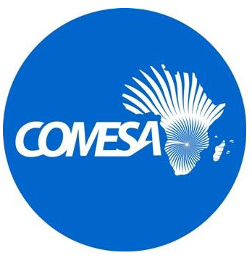

Common Market for Eastern and Southern Africa

Accelerating Sustainable & Clean Energy Access Transformation Project in AFE Region Multi-Phase Programmatic Approach
(P180547)

Final
Revised Grievance Redress Mechanism for the Project

September 2026

1. Introduction
The Common Market for Eastern and Southern Africa (COMESA) has partnered with the World Bank to support participating countries in the implementation of the Accelerating Sustainable and Clean Energy Transformation Multi Programmatic Approach (ASCENT MPA) Project to increase access to electricity services in Eastern and Southern Africa (AFE) Region. The ASCENT MPA is set to be a transformational project, with $5billion set aside by the World Bank, and a further $10billion expected to be leveraged from other cooperating partners, resulting in 100 million people with new electricity connections over a 7-year period.
This includes ASCENT-GREEN, which is a regional program developed in partnership with the Green Climate Fund (GCF). The ASCENT-GREEN Program aims to support people in the Eastern and Southern Africa (AFE) Region who lack access to modern energy, particularly those living in remote areas and fragile and conflict contexts, to become more resilient in the face of climate change. It supports private sector companies to deliver access to distributed renewable energy (DRE) systems (like solar home systems (SHSs) and renewable energy mini-grids), clean cooking solutions, and productive uses of energy (PUE) equipment, aiming to benefit about 42.6 million people in AFE, including 28.8 million direct beneficiaries and 13.8 million people who will indirectly benefit from the program providing electricity to public facilities like schools and health clinics. To this end, ASCENT-GREEN will mobilize US$1.372 billion of catalytic financing (including US$250 million Green Climate Fund [GCF] plus US$445 million World Bank/Trust Fund [TF] co-financing, together with US$521.2 million from the private sector and US$156 million from other international finance institutions [IFIs]) to implement regional financing instruments and capacity building activities
COMESA is implementing the $55 million regional platform (US$50 million IDA and US$5 million GCF grant) which consists of the following components:
- Component 1: Digital Monitoring, Reporting and Verification (D-MRV) Platforms for Energy Access and Climate Finance
The Project will support countries with adoption of digital monitoring and verification (D-MRV) platforms and other digital tools to facilitate better and faster planning, implementation, monitoring, reporting and verification of their energy access efforts and enable access to climate financing, including through their participation in carbon markets.

- Component 2: Project Preparation Facility
The Project Preparation Facility (PPF) is one of the critical components of ASCENT, which will support governments and the private sector to develop bankable, investment-ready Projects through a demand-driven approach. This component has three sub-components which are: Sub-component 2A: National agencies Project; Sub-component 2B: Cross-border solutions; and Sub-component 2C: Provision of technical advisory services, including business development grants, to eligible private-sector distributed renewable energy (DRE), productive use of energy (PUE) and clean cooking companies, DRE financiers, industry associations and not-for-profit entities supporting the DRE sector.
- Component 3: Advisory support to governments on planning, policy regulation and finance mobilization
This component will support participating countries on strengthening the policy and regulatory environment for energy access.

- Component 4: Knowledge exchange, convening, data, skills development and consumer engagement
This component will enable participating countries to share both technical knowledge and experiences of energy access interventions, allowing countries with large energy access deficits to learn from faster-electrifying countries in the region, through regional and bilateral knowledge exchanges and workshops for governments, private sector, development partners, etc. It will, among others, improve energy data availability and quality across the region, strengthen COMESA’s gender agenda and accelerate closing of gender gaps related to energy access, develop skills in the DRE sector; and establish and implement a coordination mechanism for ASCENT-GREEN.

- Component 5: Project management and capacity building support to PIU
This component will provide specific support to building the capacity of the COMESA PIU for the implementation and monitoring of the activities under the regional platform, including monitoring and evaluation and supporting the management of DRE, PUE, environmental and social, and gender aspects of the Project..
The ASCENT project has established a Grievance Redress Mechanism (GRM) which is aimed at facilitating awareness and resolution of complaints and grievances about the regional platform of the ASCENT project, implemented by COMESA.
2. Scope
The GRM is intended to receive feedback from internal and external stakeholders on the quality of services, complaints about shortcomings, failures, or dissatisfaction with service delivery, as well as issues regarding any aspect of project implementation, and to ensure their processing and follow-up. In this regard, the mechanism will handle complaints relating to:
(a) Internal Stakeholders
(i) Workplace Sexual Harassment;
(ii) Delayed Payment of wages/salaries;
(iii) Discrimination in award of salaries/wages for equal work due to gender or racial considerations;
(iv) Misconduct of any kind which would discredit COMESA and the Project, or which would cause harm to a worker; and
(v) Dismissal including summary.
(b) External Stakeholders
(i) inadequate or lack of stakeholder consultations;
(ii) Exclusion of some segments of society and/or some stakeholders from participation in project activities;
(iii) Failure to incorporate stakeholder views in subproject decision or final study documents; and
(iv) Inadequate or lack of information disclosure to stakeholders etc.
(v) Sexual exploitation and abuse (SEA)

3. Objectives
The objectives of this GRM are to:
- Provide procedures for harmonious resolution of complaints and grievances for internal and external project stakeholders arising out of the implementation of the ASCENT project;
- Create a working environment characterised by fairness, consistency, accountability and transparency in dealing with employees’ and stakeholders’ obligations and rights throughout the implementation of the project amongst the relevant stakeholders;
- Resolve any emerging environmental and social grievances in project implementation areas; and
- Promote relations between the project implementers, executers and beneficiaries.

4. Awareness
The GRM will be publicized among stakeholder groups such as the affected communities, government agencies, workers, and civil society organizations.
5. Grievance Management Procedures
The GRM will be implemented through the following procedure shown in Figure 1:

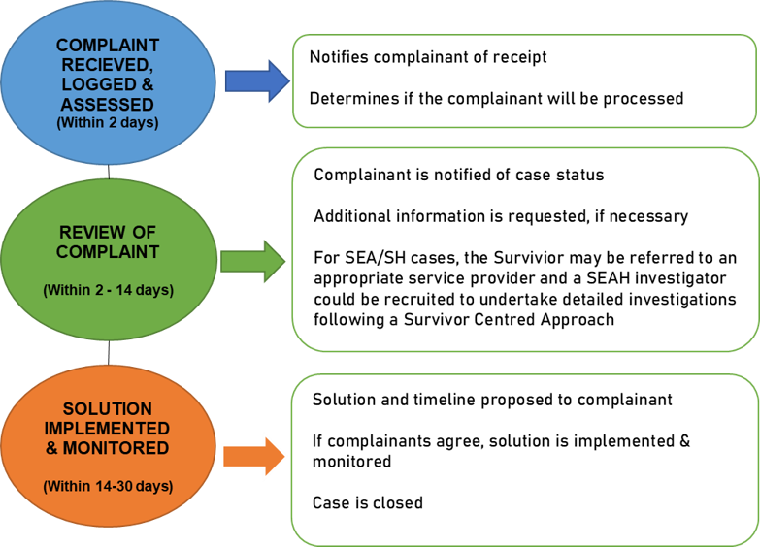

Figure 1: Procedure of handling complaints

The following are the contact details for submission of complaints:
📧 Email: grmascent@comesa.int
📞 Phone: +260 211 229725 / 229732
💬 WhatsApp: +260 772 909403 / +260 773 000254
✉️ Mail:
ASCENT Programme Coordinator
Infrastructure and Logistics Division
COMESA Secretariat
COMESA Centre, P.O. Box 30051
Lusaka 10101, Zambia
🏢 In Person:
ASCENT Programme Office
COMESA Secretariat, Ben Bella Road, Lusaka, Zambia
🚨 For complaints related to sexual misconduct:
Email our SEA/SH focal points at seah_ascent@comesa.int
🗣️ During Events:
Raise concerns during project-organised meetings, conferences, or workshops.
6. Communication channels
Communication channels for the GRM include: a web portal/email address to allow citizens, residents, and corporations to submit their enquiries, complaints and suggestions to the project at any time.
Complaints, suggestions and compliments can be submitted in person and via email and postal mail. Queries can be submitted via COMESA telephone line.
7. Appeal
If the complainant is not satisfied with the resolution proposed by the COMESA Secretariat, he/she can file an appeal to the Secretary General within 14 days of receipt of the proposed resolution and the Secretary General shall provide a decision within 10 working days.
Any party that is not satisfied with the decision of the Secretary General may refer the matter to the Court of Justice within three (3) months of the decision. The decision by the COMESA Court of Justice shall be final and binding upon the parties.
8. Sexual Exploitation Abuse /Sexual Harassment Grievance Mechanism
Given that most GBV cases at the workplace are not reported because of the fear of victimization, anonymous reporting channels will be provided as part of ASCENT grievance communication points to encourage reporting of Sexual Exploitation Abuse/Sexual Harassment (SEA/SH) related cases. When such a case is reported, the complainant shall be provided with information about the available services including confidentially appropriate medical, psychological support, emergency accommodation, and any other necessary support services as appropriate including legal assistance. The Social Safeguard Specialist shall refer all SEA/SH survivors to relevant GBV service providers in the entire referral pathway. When a case of that nature is reported, the Social Safeguard Specialist will record the case with the following limited information: the nature of the incident, the age and sex of the complainant, and whether the survivor was referred to a service provider.
The ASCENT MPA grievance committee will review all cases referred to it to determine and agree upon a course of action for handling and resolving the case. The case will be reviewed, and appropriate disciplinary action may be taken in accordance with the employer’s code of conduct and national legislation. Disciplinary actions may include verbal warning, written warning, loss of salary, suspension, or termination of employment. A survivor may continue to receive support from the appropriate GBV service providers while the case is being handled by the employer.
9. World Bank Grievance Redress Service
Communities and individuals who believe that they are adversely affected by a Project supported by the World Bank may submit complaints to existing Project-level grievance mechanisms, and other country/regional level grievance redress systems, or the Bank’s Grievance Redress Service (GRS). The GRS ensures that complaints received are promptly reviewed to address Project-related concerns. Project affected communities and individuals may submit their complaint to the Bank’s independent Accountability Mechanism (AM). The AM houses the Inspection Panel, which determines whether harm occurred, or could occur, because of Bank non-compliance with its policies and procedures, and the Dispute Resolution Service, which provides communities and borrowers with the opportunity to address complaints through dispute resolution. Complaints may be submitted to the AM at any time after concerns have been brought directly to the attention of Bank Management and after Management has been given an opportunity to respond. For information on how to submit complaints to the Bank’s Grievance Redress Service (GRS), visit http://www.worldbank.org/GRS.
For information on how to submit complaints to the Bank’s Accountability Mechanism, visit https://accountability.worldbank.org .

